SLK Frameset
Status: Complete
Last Updated: 10/26/2006 6:56 AM

1. Summary 1
1.1. Background 1
1.2. Related Links 2
2. SLK Frameset 2
2.1. Appearance 2
2.1.1. M2 Design Changes (MLC+SLK) 2
2.1.2. Title Frame and Window Title 3
2.1.3. Table of Contents Frame (MLC+SLK) 4
2.1.4. Buttons (MLC+SLK) 6
2.1.5. Frameset Communication with the Lobby and Grading Pages 6
2.1.6. Error/Information Page Format (MLC+SLK) 7
2.1.7. State Change Messages while in Frameset (MLC+SLK) 8
2.1.8. Displaying multiple messages (MLC+SLK) 9
2.1.9. Continue with current activity (MLC+SLK) 9
2.1.10. Please Wait… (MLC+SLK) 10
2.1.11. Frameset Error Conditions 11
2.2. E-Learning Session and Content Views 17
2.2.1. Accessing a View 17
2.2.2. Execute View 17
2.2.3. Grading View 19
2.2.4. Learner Review View 20
2.2.5. Instructor Review View 20
3. Design Decisions and FAQ 21
3.1. Why don’t we store all interactions for SCORM content? 21
3.2. Continue with current activity after error 21
3.3. SLK Grading View 22
4. Proposed Design Changes 22
5. Spec History 22

Summary
The frameset is the web-based interface for viewing and attempting e-learning content in SharePoint Learning Kit.

This spec describes the UI changes and e-learning session view behaviors of the SLK frameset. The original MLC frameset was developed during M1 and this spec describes changes to that design required for the SLK application.

Background
MLC provides a basic frameset for applications to use as-is or with modification. The SLK frameset is a modified version of the MLC frameset.

Unless otherwise specified, features described in this spec are SLK frameset features. Where applicable, some features should be included in both the SLK and MLC framesets. These features are identified by “(MLC+SLK)” following the section heading.

Related Links
SLK Core Concepts – Core technical concepts for SLK.
MLC Frameset ISpec – The implementation of the MLC frameset code.
SLK Frameset ISpec – The implementation of the SLK-specific frameset code.
LRM Interactions ISpec – How LRM content is handled in each learning session view.
Learning Session ISpec – Implementation of MLC learning session code.
Learning Session States ISpec – The valid operations for each MLC learning session view.

SLK Frameset

Appearance
When the frameset is launched, it opens in a new window. The M1 MLC frameset design is as mocked-up at \\juma\private\EricLe\Frameset-T!-4\Default.htm and implemented in the Basic Web Player sample application, \\juma\basicwebplayer.

M2 Design Changes (MLC+SLK)
For M2, SLK and MLC will use the same frameset design as the M1 MLC frameset, except for the following change:
- In both framesets, modify the previous and next buttons to point left and right respectively. To get the shadows and highlights correct, the existing icons need to be rotated 90 degrees and then flipped vertically for the gradient to look correct. New buttons are located at: http://nisd/sites/MLSSpecs/Specs/Forms/AllItems.aspx?RootFolder=%2fsites%2fMLSSpecs%2fSpecs%2fSupporting%20Documents%2fMockups%2fM2%20Frameset&View=%7b74D2160E%2d2EE1%2d472F%2dB54E%2d47D58B08AF30%7d.

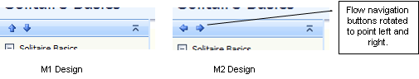

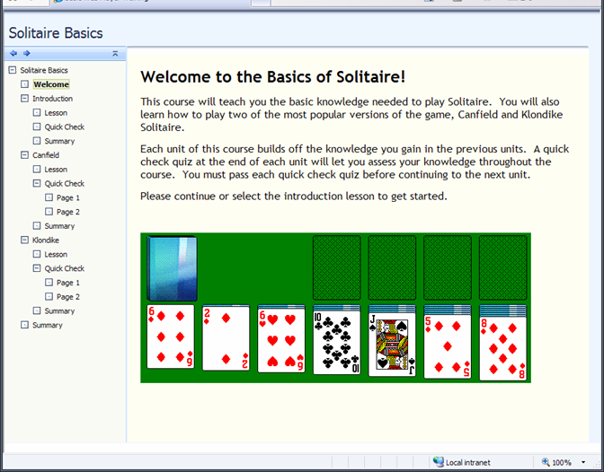

M3 DCR: Frameset General Appearance changes

In order to improve the frameset appearance and usability, the following changes are proposed for M3.

<insert new design>

- New next/previous buttons to be larger and easier to use.
- Add next/previous buttons to the bottom frame
- Change the navigation bar frame image to remove the white sliver currently in the design above the content frame.
- Remove the right scroll-bar removal frame.

Title Frame and Window Title
The frameset window title is “SharePoint Learning Kit”.

For each view, the title frame should display the title as described in the table below. The title should wrap as necessary and the frame should scroll if required.

View | Title Frame Text | Description
Execute | <Learner Assignment Title> | This is the title of the learner assignment stored in the schema.
Grading | <Learner Name>: <Learner Assignment Title> | Learner name is pulled from the MLC database.
Instructor Review | <Learner Name>: <Learner Assignment Title>
Learner Review | <Learner Assignment Title>

Table of Contents Frame (MLC+SLK)
The table of contents frame displays the activity tree for the organization presented in the frameset. It is rendered according to the frameset mockup design in section 2.1. The user may choose activities in the table of contents to deliver them in the content frame.

Is Visible
SCORM 2004 can set an activity to not be shown in the TOC by setting an IsVisible property to false in the imsmanifest.xml. SLK/MLC will not display those nodes in any view in the frameset.

An invisible node may be deliverable via flow navigation from selecting or flowing to its parent depending on other sequencing rules defined for the activity tree.

Disabling Nodes (M3 Feature)
For SCORM 2004 simple sequencing, the ability to navigate to an activity by selecting that activity in the table of contents is dependent on the current state of the data model.

The SLK and MLC framesets will disable nodes in the table of contents that are not valid for choice navigation in execute view. This informs the user what navigation options are valid and helps the user to not make illegal navigation requests.

When a node is disabled, it is grayed out and unable to be selected. Disabled nodes do not have the hover highlight on mouse-over. In review and grading views, all nodes are enabled and selecting a cluster flows to the first deliverable activity in that cluster.

The user’s view of available navigation options should match the current state of the data model stored on the server. For example, the TOC will be updated anytime the data model is committed.

M3 DCR: Update nodes after data model changes that may affect sequencing rollup

If we find it is disruptive to only update navigation options when the data model on the server changes, we may be able to update the TOC when any seqnav affecting data model element changes on the client. We would likely want to implement with a 1 sec. buffer so for large data model updates we don’t update the TOC after every SetValue. For example, if a SetValue occurs on one of the target data model elements, we will check one second later to see if there have been any other updates. If there have been more updates, then we reset the 1 second check. This will update the TOC roughly one second after the data model elements are modified.

M3 DCR: Minimize TOC if only one leaf activity

In many cases, content creators wrap all of their navigation and interaction within a single SCO. In those cases, the TOC is not very useful. This proposal is to automatically minimize the TOC in cases where there is only one leaf activity.

Selecting a cluster node (M3 Feature)
In M1, selecting a cluster node expanded or collapsed the cluster. SeqNav section 3.2.1 specifies that if the cluster’s parent has Sequencing Control Mode Choice = true, then the user should be able to choose the cluster.

The MLC and SLK frameset will implement selecting the name of a cluster node in the TOC as follows.

Expanding and Collapsing:

- Selecting a cluster node will not expand or collapse that node.
- Selecting the +/- icon on the cluster will expand/collapse the cluster.
- When an activity is delivered, all clusters leading to the delivered activity from the root of the activity tree are expanded.

SCORM 2004
- If the cluster is valid target for choice, then
  - If cluster has flow=true, then flow to first deliverable activity

    - The delivered activity should have the focus highlight and the title should be bold to indicate that activity is displayed in the content frame.
  - If cluster has flow=false, then
    - No new activity is delivered.
    - The cluster will get the focus highlight, but the current activity will continue to have a bold title indicating it is active and displayed in the content frame.
- If cluster is not valid target for choice, then

  - The cluster node is disabled per section 2.1.3.2 and cannot be selected.

SCORM 1.2
- If the selected cluster references a resource then
  - Present the referenced resource. The cluster should have both the focus highlight and the bold title.
- If the cluster does not reference a resource

  - The cluster is disabled indicating that the cluster itself does not deliver an activity.

LRM
- LRM content does not have activity clusters.

The TOC will keep the current / and icons for cluster and leaf nodes respectively. Cluster nodes in SCORM 1.2 will use the / icon, even in cases where the item also references a resource.

Selecting or will collapse or expand a cluster as currently implemented. A SCORM 1.2 cluster that references a resource will only deliver that resource when the item title is selected, not when the cluster is expanded or collapsed.

Buttons (MLC+SLK)
The frameset has the following buttons located as specified in the mockup:

Button | Tooltip | Hover | Function
Previous - | “Previous” |  | Previous navigation request
Next - | “Next” |  | Continue navigation request
Save - | “Save” |  | LRM: Save current form data and commit datamodel.  SCORM: Commit data model.
HideTOC - | “Hide Contents” |  | Hide the table of contents
ShowTOC - | “Show Contents” |  | Show the table of contents

M3 DCR: Disable next or previous button when the button is shown, but the action is not available
Currently, unless hideLMSUI hides the buttons (see 2.1.4.1), the next and previous buttons are displayed and available at all times regardless to whether the actions are valid. This change would disable the buttons if their corresponding action is not a valid navigation request. This is similar to the ADL sample RTE, except we will disable the button rather than hide it.

Button | Tooltip | Hover | Function
PreviousDisabled - | None
NextDisabled - | None

hideLMSUI
SCORM content can hide the next and previous buttons from the user by specifying <hideLMSUI> elements for an activity in the CAM.

If <adlnav:hideLMSUI>previous</adlnav:hideLMSUI> or <adlnav:hideLMSUI>continue</adlnav:hideLMSUI> is set, then the frameset will not display the respective buttons.

Hiding the next or previous buttons will not relocate the other buttons in the frameset.

See section 5.2.1.1.1.1 of the CAM for more information on hideLMSUI.

Frameset Communication with the Lobby and Grading Pages
The frameset is typically launched from the lobby (execute/learner review) or grading page (grading/instructor review). See the SLK Assignment Workflow UI spec for workflow.

- While the frameset is displayed, it is not required to update any assignment information on the grading or lobby pages.
- When the frameset closes after being launched from the lobby page, it should refresh the lobby page to update the current learner assignment state information.
- When the frameset closes after being launched from the grading page, it should update the learner assignment computed points value and apply the change in computed points to final points in the grading chart without refreshing the entire page.

See “Changes to computed points and final points” in the SLK Core Concepts spec for specifics on how final points should be updated by the computed points delta.

Broken Communication with Lobby or Grading
If communication between the frameset and the grading page is broken (e.g. from refreshing the frameset window), the following alert is displayed.

“Changes to this page will no longer be reflected in the grading page when you close this window. To fix this, save your changes and re-open the assignment from the grading page.”

If the frameset was launched from the lobby page, ignore the communication reset and do not display an alert to the user.

Error/Information Page Format (MLC+SLK)
Errors are shown in the following standard information page format:

Item | Style
ErrorBody | background-color: #f9faf3;  color: #42507e;  font-size: 11px;  font-family: Tahoma, Arial, Helvetica, sans-serif
ErrorTitle | font-size: 16px;  font-family: Tahoma, Arial, Helvetica, sans-serif
ErrorMessage | font-size: 12px;  font-family: Tahoma, Arial, Helvetica, sans-serif

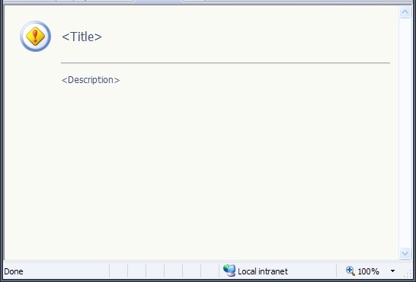

A mockup of the error page is available at http://nisd/sites/MLSSpecs/Specs/Supporting Documents/Mockups/SLK Frameset/error.htm.

There are two types of error messages:

Type | Icon | Condition
Error |  | If the user or system has an error that is unrecoverable or does not allow the user to continue their workflow unaffected.
Information |  | If the message is for informational purposes and the user’s workflow is otherwise unaltered.

If an error or information message is about the rendering of the frameset such that either the frameset is unable to fully render or the user is unable to use the frameset and its controls, then the message is displayed in the full browser window. If the message is about the content displayed in the frameset, then the message is displayed in the content frame.

State Change Messages while in Frameset (MLC+SLK)
When executing content in the frameset and a state change occurs that ends the current session, an information message is displayed in the content frame without the table of contents. This is done because the user can no longer interact with the assignment.

Examples when this occurs are:
- ExitAll, SuspendAll, AbandonAll commands
- Instructor collects the assignment

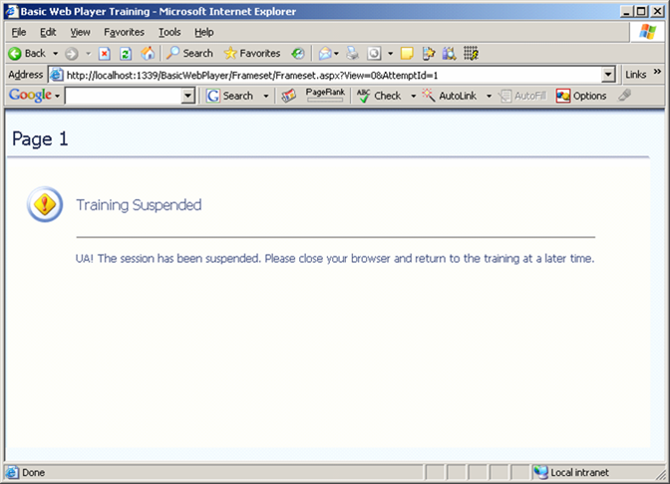

Displaying multiple messages (MLC+SLK)
In some errors, exception strings or other detailed information are displayed in an error or information message. For cases where there are multiple “more information” strings displayed, “More Information:” will be rendered once on a new line and followed by a bulleted list of the messages.

For example:

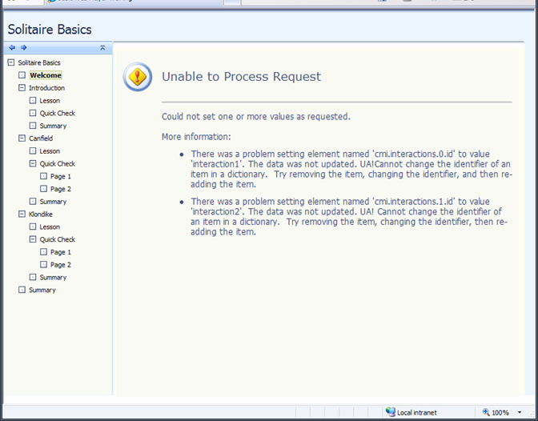

Continue with current activity (MLC+SLK)
Some errors break the assignment sequencing and navigation flow and should allow the user to return to their current activity. Examples include making a navigation request that is undeliverable due to seqnav rules (see section 2.2.3.1), or having an asynchronous commit error on the server that interrupts the user with an error message.

In these cases, the error messages will use standard error formatting and will include a Continue link on a new line at the end of the message that does the following:
- If the current activity is still active, return to the current attempt of the current activity.
- If the activity is not active, choice navigate to the current activity.

For example:

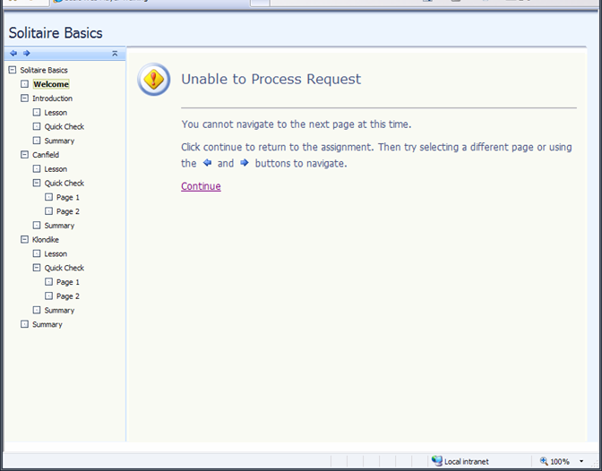

M3 DCR: Display error in a separate frame to avoid exiting current activity attempt

For content that exits with cmi.exit=normal in the unload event of the page, the current attempt for that activity may end when displaying error messages. If that activity has an attempt limit or is otherwise not able to be attempted again, the user may not be able to return to the activity.

One option to investigate is to display errors in a separate frame that displays in place of the content frame, and leave the current activity in the content frame. The continue link would then clear and remove the error frame and return the user to the content frame with the content in its pre-error state. This could solve the issue because the content frame never unloads the activity.

Please Wait… (MLC+SLK)
When the frameset performs operations that may take 0.5+ seconds to perform, a “Please Wait…” page is displayed in the content frame. The text is centered in the page and uses the same font style as the error/information title.

The page will have a 0.5 second delay when displaying to reduce disruptive flashing for typical fast page loading events.

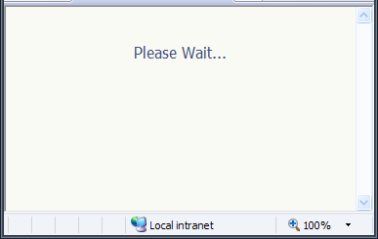

A mockup of the please wait page is available at http://nisd/sites/MLSSpecs/Specs/Supporting Documents/Mockups/SLK Frameset/PleaseWait.htm.

Frameset Error Conditions

Content Access Errors
Condition | Title | Message | Type | Comments
Date is before Assignment Start Date | Assignment Not Available | This assignment is not available.  Most likely causes:  - The assignment does not exist.  - You are accessing an assignment prior to its start date.  - You do not have access to the requested view of the assignment.  More information may be available in the server event log. | Error
User doesn’t have access to the assignment
General exceptions
Entire e-learning package, as opposed to the individual page, cannot be found or has been modified since the time it was assigned. | Assignment Resource Not Available | The version of the learning resource assigned for this assignment cannot be found because it has been deleted or modified. | Error
User is not signed in to SharePoint | Assignment Not Available | You must sign in to access this assignment. | Error
Cannot access execute view because LearnerAssignmentState > “Active” | Assignment Not Available | This assignment is not available because it has been submitted as complete.  You can review this assignment after it is returned by your instructor. | Error | See add date/time DCR to add when the assignment was submitted as complete.
Cannot access grading view because LearnerAssignmentState < “Completed” | Grading Not Available | You cannot grade this assignment until it has been submitted.  To enable grading, you can collect the assignment or have the learner submit the assignment. | Error | An instructor can access grading view in the “completed” and “final” states.
Cannot access learner review view because LearnerAssignmentState < final | Review Not Available | You cannot review this assignment until it has been returned. | Error
Cannot access instructor review view because LearnerAssignmentState = NotStarted | Review Not Available | You cannot review this assignment until it has been started by the learner. | Error

LRM Execute Errors

Condition | Title | Message | Type | Comments
File Attachment Error | File Attachment Error | {FileTypeNotAllowed}  {SizeExceeded}  Administrators can change the file attachment settings in SharePoint Central Administration by modifying the SharePoint Learning Kit settings file.  Continue | Error | Display this message if either or both file attachment errors occur. Display FileTypeNotAllowed before SizeExceeded if both errors occur at the same time.  Continue links back to the previous (current) LRM page.
Maximum Attachment Size Exceeded  ({SizeExceeded}) |  | The attached files listed below are larger than the allowed limit of <size limit> KB. Reduce the size of these files and try again.  Invalid files:  {0} |  | 0 = Bulleted list of files exceeding the size limit.
Attached file is not one of the allowed types  ({FileTypeNotAllowed}) |  | The attached files listed below are not allowed file types.  Invalid files:  {0} |  | 0 = Bulleted list of files with invalid file types.

M3 DCR: Inject error messages and/or do not lose data during error in class server content

The current implementation for displaying errors in execute view for LRM resources is to replace the page with the appropriate error page. This can be disruptive if there is a single interaction error, for example the attachment size is exceeded. In that case all other interaction responses are lost when the error page is displayed.

This DCR would:
Save the non-error interaction responses, so work is not lost.
Inject the error message in the content page so the user has more context for the error.

Note that current functionality is the same as current Class Server behavior, and injecting errors into content can be risky.

Assignment Finished Messages
Display the following information messages when an assignment is finished or suspended. Use the same messages when the assignment is auto-returned. In those cases, the learner will close the frameset to see the updated state and resume/review button on the lobby page.

Condition | Title | Message | Type | Comments
ExitAll results page (includes adl.nav.request and postConditionRule action) | Assignment Complete | This assignment has been submitted as complete. You cannot make any further changes. | Info | Full content frame no TOC (see 2.1.7)
Results page after clicking “submit” on the frameset submit page
AbandonAll results page (includes adl.nav.request and postConditionRule action) | Assignment Abandoned | This assignment has been abandoned. You cannot make any further changes. | Info | Full content frame no TOC (see 2.1.7)
SuspendAll results page | Assignment Suspended | This assignment has been suspended. You can return later to resume the assignment. | Info | Full content frame no TOC (see 2.1.7)

M3 DCR: Add date and time to training finished messages

Add date and time to the assignment complete messages to inform the user when the assignment was complete or abandoned. The new messages would be of the form:

“This assignment was submitted as complete on <DateLongFormat> at <TimeShortFormat>. You cannot make any further changes.”

This DCR would require adding date/time submitted LearnerAssignments in the database.

MLC Frameset UA Strings (MLC)
The following UA strings documented here are MLC strings for the frameset.

Name | String | Comments
FRM_Title | Basic Web Player Training | BWP only – SLK should be “SharePoint Learning Kit”
FRM_ParameterRequiredTitle | {0} Parameter is Required | 0=name of parameter (not localized)
FRM_ParameterRequiredMsg | The {0} parameter is required in order to display the training. | 0=name of parameter (not localized)
FRM_InvalidParameterTitle | Invalid Parameter Value
FRM_InvalidParameterMsg | The value ({1}) is not valid for the {0} parameter. | 0 = name of parameter (not localized); 1 = the value provided for the parameter
FRM_UnknownExceptionTitle | Error
FRM_UnknownExceptionMsg | An error occurred. More information: {0} | 0=message from exception
FRM_InvalidAttemptStatusForViewTitle | Training Not Available
FRM_ExecuteViewAbandonedSessionMsg (Abandoned) | This training has been abandoned. You cannot make any further changes. | Full content frame no TOC (see 2.1.7)
FRM_ExecuteViewCompletedSessionMsg (Complete) | This training has been completed. You cannot make any further changes. | Full content frame no TOC (see 2.1.7)
FRM_ExecuteViewSuspendedSessionMsg (Suspened) | This training has been suspended. You can return later to resume the training. | Full content frame no TOC (see 2.1.7)
FRM_CannotDisplayContentTitle | Training Not Available
FRM_SessionIsNotActiveMsg | This training has been completed. You cannot make any further changes. | Full content frame no TOC (see 2.1.7)
FRM_ActivityIsNotActiveMsg | The page cannot be displayed. Select a different page.
FRM_UnexpectedError | An error occurred. More information: {0} | 0= exception message
FRM_UnexpectedErrorTitle | Error
FRM_ViewNotSupportedTitle | View Not Supported
FRM_ViewNotSupportedMsg | Random access view is not supported in this application. | For other views, “Random access” is replaced with “Review” or “The requested view” as appropriate for the view requested.
Error displaying error pages | The page you requested cannot be displayed. Try refreshing your browser to continue. | This error is displayed when there is an error visiting a previous error page.
HID_MoveNextFailed | You cannot navigate to the next page at this time. Click Continue to return to the current page.  Continue | For SLK the second sentence should read: “Click Continue to return to the assignment.”
HID_MovePreviousFailed | You cannot navigate to the previous page at this time. Click Continue to return to the current page.  Continue | For SLK the second sentence should read: “Click Continue to return to the assignment.”
HID_MoveToActivityFailed | You cannot navigate to the selected page at this time. Click Continue to return to the current page.  Continue | For SLK the second sentence should read: “Click Continue to return to the assignment.”
HID_SetValueFailed | Could not set one or more values as requested.  More information: | Following this message, one or more messages from exceptions are displayed.
HID_SetValueMappingFailed | Could not set one or more values as requested.  More information: | Following this message, one or more messages from exceptions are displayed.
HID_SetValuePostedDataInvalid | Data posted about the data model was invalid. | This message is displayed as the "More information" part of HID_SetValueFailed or HID_SetValueMappingFailed
HID_InvalidActivityId | The activity id {0} is not valid. | 0=activity id sent to request as the target activity
HID_TerminateFailed | There was a problem processing a request from this page. Try selecting a different page.  More information: {0} | 0=message from exception
HID_ServerErrorTitle | Processing Error
CONV_MappingRequired | Interaction and objective information has not been properly initialized.
CONV_SetValueComment | There was a problem adding or updating comment data associated with this page.  More information: {0} | 0=information from exception
CONV_SetValueInteraction | There was a problem adding or updating interaction data associated with this page.  More information: {0}
CONV_SetValueInvalidName | The element named '{0}' could not be recognized. The data was not updated. | 0=the invalid name.
CONV_SetValueInvalidValue | The value ({0}) is not valid for the {1} element. The data was not updated. | 0=value, 1=element name (eg, cmi.score.raw)
CONV_SetValueObjective | There was a problem adding or updating objective data associated with this page.  More information: {0}
CONV_SetValueReadOnly | The '{0}' element cannot be modified. The data was not updated. | 0=name of the element
CONV_SetValueException | The value ({0}) is not valid for the {1} element. The data was not updated. More information: {2}. | 0 = element name, 1 = attempted element value, 2 = exception message
CONV_InvalidViewOnSetValue | The data on this page cannot be updated while reviewing the training.
CON_PleaseWait | Please wait... | Message to wait for other frames to load.
CON_ContentCannotBeDisplayedTitle | Cannot Access Content
CON_ContentCannotBeDisplayedMsg | There is a problem accessing the content. It cannot be displayed. | This is a generic error message that happens when the content URL is not valid. It should not contain much information because it basically means either there is a bug in the frameset or this is a hack attempt.
CON_ResourceNotFoundTitle | File Not Found
CON_ResourceNotFoundMsg | The page you requested cannot be found. Please select or move to a different page. | This message is displayed when a page in the package cannot be found. Not a security issue because the learner basically has full access to the package if it is assigned to them.
TOC_InvalidJsVersion | The browser has cached an old version of files required for this page. Please refresh your browser.

E-Learning Session and Content Views
SLK and MLC present e-learning content in the frameset by view. Views control what is available to the user in the frameset and how the content behaves. This section describes the SLK-specific content view behaviors, and how SLK controls access to the views.

More specific definitions of the MLC views are available in the Learning Session and Learning Session States ISpecs. LRM interactions and how they are rendered in each view are defined in the LRM Interactions Implementation Spec.

Accessing a View
View access is restricted based on the learner assignment state and the user’s relationship to the learner assignment.

The table below specifies the conditions required to access the SLK views. The access conditions are checked for each page view and the appropriate error is displayed if the user no longer has access to the target view (see 2.1.11).

SLK View | Conditions to Access View
Execute | - Current user is the learner for the target learner assignment  - LearnerAssignmentState < “Completed”
Grading | - Current user is an instructor for the learner assignment’s assignment  - LearnerAssignmentState > “Active”  - Note grading view may be accessed in both the “completed” and “final” LearnerAssignmentStates.
Learner Review | - Current user is a learner for the target learner assignment  - LearnerAssignmentState = Final
Instructor Review | - Current user is an instructor for the learner assignment’s assignment  - LearnerAssignmentState > NotStarted

Execute View
When a learner attempts a package, they do so in execute view. This view uses the standard seqnav operations and maintains a data model for the user’s interactions with the content. For LRM, execute view displays the content with user answers, points possible, and non-hidden rubrics. LRM does not display hidden rubrics, inline scores, instructor comments, or correct answers in execute view.

Creating an Attempt
If a learner launches an assignment in the SLK frameset and the e-learning attempt is not yet created, a new attempt will be created for the learner and launched in execute view.

Navigation for Undeliverable Activities (MLC+SLK)
When processing a navigation request from the user or the SCO, MLC should verify that it is a valid navigation request and allow the user to return to their current attempt on their current activity if the request is undeliverable. The appropriate “cannot navigate” error is displayed in the content frame and has a link to return to their current activity.

When errors like this occur, they will be formatted according to section 2.1.9.

This allows the user to maintain and return to their current assignment state when making an invalid navigation request.

Submit Page (M3, MLC+SLK)
As in Class Server, a user can submit assignments via a submit page at the end of the content. In SLK this page is provided by the frameset and appears to the user as a final page of the assignment activity tree.

For all e-learning content, an entry called “Submit Assignment” (“Submit Training” for MLC frameset) is added to the end of the table of contents at the same level as the root organization node. The page can be accessed via choice navigation in the TOC.

The submit assignment page is treated separately from the organization and seqnav rules. The user can choose the submit page at anytime regardless of the sequencing rules. Due to the complexities of SCORM seqnav, users will not be able to flow navigate to the submit page.

In all cases the submit page will hide the LMS UI next and previous buttons to eliminate confusion and sequencing complexities of navigating to the “previous” activity. The user can click the Submit or Cancel buttons, or choice navigate via the TOC.

Clicking the Submit button submits the assignment as complete via an ExitAll command and the submitted confirmation page is displayed in the content frame as defined in section 2.1.11.3.

Clicking the Cancel button returns the content frame to the “current” activity similar to the Continue functionality for error conditions defined in section 2.1.9.

The submit page uses standard information page formatting (see 2.1.6). For the MLC frameset, replace the word “assignment” with “training” in the message below.

Title | Message | Type
Submit this Assignment? | You cannot make any further changes after you submit this assignment. | Info
  If you have completed the assignment, click Submit.
  If you are not ready to submit the assignment, click Cancel to return to the previous page.
  [Submit] [Cancel]

LRM: Storing All Interactions
When an attempt on LRM content is finished, SLK will visit every LRM activity that the user has not interacted with and store in the data model:
- Each interaction
- The correct answer for each interaction
- Min score for each interaction
- Max score for each interaction
- Autoscore
- Initialize instructor score

Note that during this operation SLK stores the interaction and correct answer if there is one, but does not record user answers for the interactions because there are no user answers for non-visited activities.

This assists with item-level analysis reporting. For LRM content, every attempt will have a full record of all the interactions. Typically interactions are stored only if the learner visits the activity containing them. Since it is possible for a user to skip activities through choice navigation, visiting every activity to record the interactions ensures that all interactions are represented in the database, regardless of whether the learner viewed them or not.

Grading View
The grading view is used for instructors to grade and comment within LRM content. The frameset displays review mode for non-LRM content.

In this view, the instructor can edit score, rubric, and comment fields, but may not edit the learner’s answers. In addition, this view has the following characteristics that are the same as Instructor Review view:

- The view always shows the correct answers, regardless of the show correct answers bit.
- Hidden tables are always displayed (see 3.4.4.4 of the Learning Resource Development Guide).

LRM Interaction Scoring
For LRM content, there is an auto-score and an instructor-score for each interaction. The grading view displays the instructor-score field for each interaction as defined in the LRM Interactions ISpec.

For autograded questions, the instructor score is initialized to the autograde score. For non-autograded questions, the instructor score initializes to null. Auto-score is stored in the database, but is not displayed in the grading view other than through the initialization of instructor-score. Unanswered autograded questions will receive an autograde of 0.

Modifying the score field modifies the instructor-score and not the auto-score. Both the auto-score and instructor-score may be null.

The sum of all instructor scores across all activities makes up the “computed score” as defined in the SLK Core Concepts specification.

Finishing Grading
The instructor can save their grades and comments to the database at anytime by clicking on the save button. To finish grading the instructor can save the grades and close the frameset.

The frameset does not handle “returning” learner assignments. A learner assignment is returned via the grading page UI (see SLK Assignment Workflow UI spec).

M3 DCR: Add a finish grading page to the frameset
If we find that using the save button and closing the frameset is not a discoverable workflow for finishing grading, we can add a finish grading page, similar to the submit page for LRM content. The page would display “Finish Grading” in the TOC. When the instructor accessed the page either via choice navigation or flowing beyond the last activity, the page would display a message that the grading information has been saved to the database. “Click here to close this window.”

Learner Review View
This view displays LRM content to the learner along with his/her answers, inline scores, instructor comments, and non-hidden rubrics. Note, hidden tables are never displayed in learner review view.

SCORM content is displayed in MLC review view. The display of content in review view is dependent on the content’s implementation of that view mode.

M3 DCR: Remove specific color formatting for LRM grades and comments

In Class Server, the user’s answers, correct answers, interaction score, and instructor comments are rendered in a specific color. This limits the flexibility of the content creator. For example, scores and correct answers are maroon, which will not work well with most dark content backgrounds.

This DCR would change how the grading information is displayed to the user to remove the specific formatting. This is not a main feature because the current solution maintains existing CS4 functionality and the change may not be trivial.

The suggested new styles are:

Item | Style
User’s answers | Times, bold (change from black)
Correct answers | Arial, italic (change from maroon)
Interaction score | Arial, bold or script font (change from black)
Instructor comments | Arial, italic or script font (change from maroon)

Show Correct Answers
If the show correct answers property is checked, then any learner assignment with LRM content that is viewed in learner review mode will display the correct answers in addition to the learner’s answers.

If this property is not checked, then the learner will only see their answers. Note that this property may be changed at any time. For example, the assignments could be manually returned to students to allow them to review their answers, but the instructor may choose to "show answers" only after she has returned all of the assignments.

Instructor Review View
The instructor review view behaves identically to learner review, but the view has the following additional characteristics:

- The view always shows the correct answers, regardless of the show correct answers bit.
- Hidden tables are always displayed (see 3.4.4.4 of the Learning Resource Development Guide).

M3 DCR: Answer Key View
An answer key view for an Assignment would be very similar to InstructorReview, but for a general assignment rather than a particular learner assignment. It would display the content with correct answers, available points, and all scoring rubrics. All activities would be available through choice and next navigation.

Design Decisions and FAQ

Why don’t we store all interactions for SCORM content?
Section describes how all interactions for LRM content are stored. You may be asking why we don’t also do this for SCORM content. There are a couple reasons for this:

- The main reason is due to the design of SCORM. With SCORM, it is up to the content design whether or not interactions are stored in the data model. There isn’t a central model of “all the interactions in a lesson”, there is just a record of all the interactions that the content chooses to report through the SCORM API. Additionally, the content is free to record some or all of the user’s response, correct answer, raw, min, max, and scaled scores, but it is not required to store anything. This gives a great deal of flexibility to SCROM content, but it also means that the content is responsible for how to record interactions.
- The other reason is SCORM simple sequencing. Even if we could somehow identify all the interactions, it is possible through the adaptive learning capabilities of SCORM simple sequencing that some interactions were not presented to the learner. In LRM, the content standard is such that any interaction in the package is intended to be visible and available. All LRM sequencing is linear and all pages are to be viewed. In SCORM, the simple sequencing rules mean that each learner’s experience can be different and they can experience different interactions.

The thing to remember as a content developer is that the ability to provide item level analysis for SCORM content depends completely on the information the content stores in the database.

Continue with current activity after error
The ‘continue with current activity’ behavior in section 2.1.9 depends on how the content is designed. The Continue link may launch a new attempt on the activity or may rejoin the current attempt on the activity based on whether or not the current activity is still active or if the content suspends the attempt when it is terminated. For example: if the activity sets cmi.exit=”suspend” in the OnUnload for the SCO, then returning to the activity will retrieve the current attempt of that activity. If cmi.exit=”normal” then the activity attempt will terminate when unloading the SCO and “continue” will launch a new attempt of that activity.

Eventually SLK should use this in conjunction with disabling navigation controls when the content limits navigation options. For example, the user should not have the option to choose an activity that is disabled, or make a choice request when choice=false.

SLK Grading View
We originally planned to have SLK grading view use an MLC grading view that was similar to random access view, but only allowed sequencing to activities with resources. Rather than creating another MLC view, we have decided to have SLK use the random access view for grading. It has the same capability of the previously planned grading view, but additionally can access non-resource nodes in the activity tree. SLK will only access the activities with resources in its use of random access for grading view.

Note that the random access view does not execute rollup processes. If sometime in the future, someone wants a grading or random access view that can change data and process rollup actions, the current design will not support that. That would be one potential argument for keeping a grading view that could implement the rollup process. Implementing the added functionality is not a trivial cost for dev or test because performing rollup without sequencing was not in the original plans and implementation. Performing rollup in grading view is not a requirement for SLK, so we have opted to not include the functionality in V1 of SLK.

Proposed Design Changes
M3 DCR: Frameset General Appearance changes 3
M3 DCR: Update nodes after data model changes that may affect sequencing rollup 4
M3 DCR: Minimize TOC if only one leaf activity 5
M3 DCR: Disable next or previous button when the button is shown, but the action is not available 6
M3 DCR: Display error in a separate frame to avoid exiting current activity attempt 10
M3 DCR: Inject error messages and/or do not lose data during error in class server content 13
M3 DCR: Add date and time to training finished messages 13
M3 DCR: Add a finish grading page to the frameset 20
M3 DCR: Remove specific color formatting for LRM grades and comments 20
M3 DCR: Answer Key View 21

Spec History
Date | Changes Made
3/24/2006 | Spec created
5/11/2006 | Partial draft update.
5/12/2006 | Made some updates to the information/error page specification. Worked through the MLC error strings with M.A. and removed them from this spec because currently this is focused on SLK-specific frameset functionality.
5/19/2006 | First draft. Added quite a bit of material and added the MLC UA strings back in to have a place to document them.
5/24/2006 | - Added which features should be included in both the SLK and MLC framesets. Many features are specific SLK functionality, but other features make sense to be implemented in both framesets.  - Added notes that frameset text styles should be consistent with SharePoint UI, thus changed font to Verdana. Need to verify with rest of UI.  - Added clarification that grading view is for LRM content. SCORM content displays in review view.  - Learner review and instructor review views are for LRM content, SCORM content displays in MLC review view.  - Misc. other minor edits for formatting and clarification.
6/20/2006 | Appearance  - In researching SharePoint styles, they use both Verdana and Tahoma. Both are good font styles, so I switched spec back from last edit to Tahoma, which matches the current implementation.  - Created new next/prev button images and added link to them in in the SharePoint MLS Specs supporting documents.  - Removed the page title example to clarify that our page title is “SharePoint Learning Kit”.  - Changed “Allow cluster node choice navigation” DCR to a feature. It appears in reading the SCORM 2004 spec, that users should be able to choose cluster nodes if their parent has choice=true. Additionally, if the cluster has flow=true, then it should flow to the first activity in the cluster.  Error Conditions  - Added “Displaying Multiple Messages” section specifying that errors with multiple “more information” messages display those messages in a bulleted list after a single “More information:” line.  - Added “Continue with current activity" section describing the formatting of errors that should allow users to return to their current activity. These errors interrupt the user’s flow and should allow the user to return to “where they were”. The individual error messages state whether or not they have the “continue” link. This section describes the formatting.  - Removed UA!s and fixed up error message text.  - Removed “Close this window” links from error messages. This is not essential because the frameset launches in its own window. Users will understand how to close the frameset window.  - Modified HID_MoveNextFailed, MovePreviousFailed, and MoveToActivityFailed MLC error messages to include the “continue” link to return to the current activity. Also changed “can’t” to “cannot” and swapped the “next” and “previous” button images to make the message look better. (Now previous comes before next, making it look like <- and -> rather than -> and <-.)  E-learning Session and Views  - Added “Creating an Attempt” noting that when launching a new assignment in the frameset where an attempt does not already exist, a new attempt should be created and launched.  - Added section in execute view on navigating to undeliverable activities. If the user makes an invalid navigation request, then s/he sees the appropriate “cannot navigate” error and is allowed to return to their current activity.  - Added a note that the LRM submit page is not required for M2 because the M2 LRM implementation mirrors SCORM 2004 rather than the final design which will be similar to SCORM 1.2. There is no need to implement the page in the intermediate state and it can wait for the final design implementation.  - Added notes in grading view that an instructor can edit rubrics, always view the correct answers, and see all hidden tables.  - Noted in Learner Review View that SCORM 2004 review view behavior is dependent on the content’s implementation of review view. (For example, we don’t display correct answers unless the content displays the correct answers.)  Design Decisions and FAQ  - Added section on why we don’t store all interactions for SCORM content, but we do for LRM. Basically it is because SCORM is so flexible and it is left up to the content what interactions and data is reported.  - Added note about the decision to implement Grading View using MLC random access view rather than creating a separate MLC grading view. Random access view has all of the planned capabilities of grading view, but can also access non-resource nodes. SLK grading view will use random access, but only access resource nodes.
6/27/2006 | Appearance  - Updated “Displaying multiple messages” and “Continue with Current Activity” images to show the error message within the content frame rather than across the entire browser window.  - Modified POR for the “continue with current activity” link in error messages. The design now provides a continue link that chooses the current activity rather than re-rendering the current page. This change was made because the act of displaying the error message unloads the SCO, which typically exits the activity unless the content is designed to suspend. Re-rendering only worked if the current activity was still active. This design still causes users to exit their current activity even if the navigation request is not valid, so this design may change again.  - Changed “Grading Not Available” and “Review Not Available” error messages so they are easier to understand.  - Added a comment to “Grading Not Available” to clarify that grading view is available in both the “completed” and “final” states. Instructors are able to grade an assignment after it is returned.  E-Learning Session and Content Views  - Moved embedded e-mail notes to comments for CTP1 prep.  - Added Instructor Review M3 DCRs from the SLK Core Concepts spec. One is to have instructor review available for printing in the “final” learner assignment state. The other is to provide an answer key view that is similar to instructor review, but for a general assignment rather than a particular learner assignment.  Issues, Dependencies, and Risks  - Removed the “Only navigate when a requested navigation is valid” issue because it is already reflected in other DCRs and current design POR. (Continue link and hiding navigation UI).  Design Decisions and FAQ  - Added section to describe the “continue with current activity” error messages and how their behavior is dependent on the design of the content and whether the content suspends or not.
7/17/2006 | Updates from partial spec review.  - Clarified that the M1 MLC frameset is the baseline for this spec and is implemented according to the M1 mockup.  Title Frame and Window Title  - Moved the frameset window title to the top of the section for clarity. The frameset window title should be “SharePoint Learning Kit”.  - Fixed the “Preview” title. It should match the default title as specified in the create assignment page. I previously described it as the default actions title, which didn’t account for organization selection.  - The Learner Name used in the Grading and Instructor review views should be the name stored in the MLC database.  Table of Contents  - Disabling Nodes: The state of the navigation options should match the state of the data model on the server.  - Added an M3 DCR to update the TOC after data model changes on the client that may affect sequencing. This is likely unnecessary, but may be an option if the current spec’d behavior is disruptive to the user.  - Removed “M3 DCR: Disable all TOC elements when choice is not available.” It duplicated the spec’d behavior for disabling nodes.  - Clarified “selecting a cluster node” behavior.  - Modified to be an M3 feature because it will likely be implemented at the beginning of M3 along with the disabling nodes feature.  - Outlined behavior for SCORM 2004 and 1.2.  - Clarified what activities receive the bold “delivered” title and selected highlight.  - Clarified node icon and collapse/expand behavior for SCORM 1.2.
8/3/2006 | Updates from rest of spec review.  Appearance  - Removed DCR to remove the save button and automatically post data back in unload event.  - Added a DCR to minimize the TOC if there is only one leaf activity in the organization.  - Spec’d state change message formatting as an information message without the table of contents.  - Displaying multiple ‘more information’ messages in a bulleted list should be in both the MLC and SLK frameset.  - Added DCR to display errors in a separate frame to avoid exiting the current activity attempt and make returning to the ‘current state’ from the error more robust.  Error Conditions  - Removed General Frameset Rendering Error because it is covered by the Assignment Not Available error, which is used for a variety of causes including general exceptions.  - Added an Assignment Not Available error for when the current user is trying to access an assignment and isn’t signed in to SharePoint.  - Made many error string updates, mostly for consistency across frameset and rest of the product.  - Added the general exception condition to display the ‘Assignment Not Available’ message and updated the message to indicate that more information may be in the server event log.  - Removed the specified error for navigating off the beginning or end of the activity tree because the condition is covered by the navigation failed error messages.  - Modified LRM Execute Errors for consistency and restructured them because file attachment size and invalid type can both error on the same submission. Now both messages can be displayed on the same error page.  - Clarified that the ‘Assignment Finished Messages’ display regardless of assignment autoreturn property. For autoreturned assignments, the learner will have to close the frameset to see their updated state and review the assignment.  - Added a SuspendAll results message.  - Updated ‘Add date and time to training finished messages’ DCR noting the DCR would require adding date/time submitted to the database tables.  - Made many updates to the core MLC error condition strings.  - Replaced ‘LAState’ with ‘LearnerAssignmentState’ throughout the spec.  Content Views  - Clarified that Preview and Execute views will not display correct answers or non-hidden rubrics.  Submit Page  - The submit page will now be added to the end of the table of contents for all e-learning content. Prior to this change it was only for LRM content.  - Specified how the submit page should work for SCORM 2004. It is treated separately from the SCORM organization and any seqnav rules.  - Fixed the ‘Submit this Assignment?’ message and removed UA!  LRM: Storing All Interactions  - Clarified that SLK visits every LRM activity that the user has not interacted with to store all interactions. Interactions already visited by the learner are already stored in the data model.  - Added storing ‘autoscore’ and ‘initialize instructor score’ to the actions SLK performs during LRM interaction storing.
10/16/2006 | Table of Contents  - Clarified that SCORM 2004 elements with IsVisible = false are not displayed in the TOC, regardless of frameset view.  - Nodes are disabled only in execute view. All visible nodes are enabled in review and grading views. (Bug #1102)  - Clarified that disabled notes are grayed out, unable to be selected, and do not have the hover highlight on mouse-over. (Bug #1102)  - Updated expand/collapse behavior. Nodes only expand/collapse by selecting the +/- icon. The tree auto-expands when delivering an activity so the path from the activity to the root is visible. (Bug #1102)  - Added disabled next and previous buttons to the DCR in case we can fit it in.  Views  - Removed references to Preview because the feature has been cut. (Bug #1103)  Submit Page  - Submit Assignment “page” is located at the end of the TOC at the same level as the root organization node. (Bug #1104)  - Submit page is separate from package seqnav for all content types and user cannot flow to the page from the content. It must be selected from the TOC. This was done to reduce cost and risk and for consistency across content types. (Bug #1104)  - Updated submit page text. (Bug #1043)  - Submit page hides LMS UI next and previous buttons to reduce navigation confusion. (Bug #1104)  - Submit and Cancel are buttons. (Bug #1104)
10/23/2006 | Appearance  - An alert is displayed to the user if communication is broken between the frameset and the grading page. An alert is not displayed to the user if the frameset was launched from lobby because the disruption from the alert is greater than any benefit from making sure the lobby refreshes properly. In the case where it doesn’t update properly, the user can refresh the lobby page to get the update. (Bug #1084)  Error Messages  - Added error message for error in displaying previous error messages. (Bug #848)  - Added error text for when an e-learning package cannot be found or the version assigned has been modified. (Bug #738, #563)

